UID ASSIGNMENT 5

Task analysis and userflow

Sheryl Katrina.M

230701310

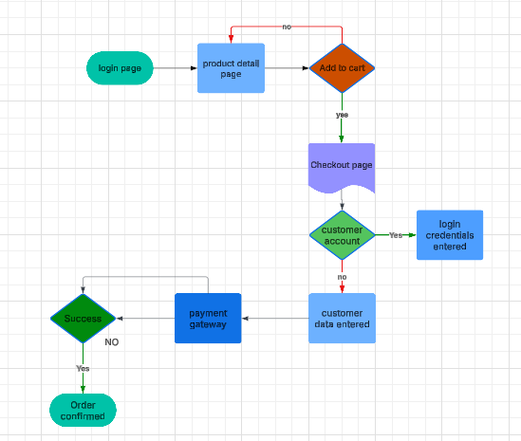

**E-commerce Website User Flow Documentation**

**1. Login Process**

* Users start at the login page.
* They enter their credentials (email/username and password).
* If credentials are correct, they are redirected to the homepage.
* If incorrect, an error message is shown, and users can retry or reset their password.

**2. Product Browsing and Selection**

* Users navigate to the product detail page.
* They can explore product descriptions, images, reviews, and pricing.
* They decide whether to add the product to the cart.
* If they choose not to add, they can continue browsing.

**3. Adding to Cart**

* When a user selects a product, they click 'Add to Cart'.
* If logged in, they proceed to checkout.
* If not logged in, they are prompted to log in before proceeding.

**4. Checkout Process**

* Users are directed to the checkout page.
* They enter or confirm customer details such as shipping address and contact information.
* If they already have an account, the saved information is auto-filled.

**5. Payment Processing**

* Users select a payment method (Credit Card, PayPal, etc.).
* They are redirected to a secure payment gateway.
* If payment details are valid, the transaction proceeds.
* If payment fails, users are prompted to retry or use another method.

**6. Order Confirmation**

* If payment is successful, the order is confirmed.
* Users receive an order confirmation notification via email/SMS.
* They can track their order in the 'My Orders' section.

**7. Post-Purchase Support**

* Users can review orders, request returns, or contact customer support.
* The system updates users about order status (shipped, delivered, etc.).
* If users face issues, they can raise a complaint or request refunds.

This structured process ensures a smooth, secure, and user-friendly shopping experience.